**SYSTEM DESIGN & UML REPORT**

**Project Title: Snack Dispenser System**

**1. Overall System Description**

**1.1 Introduction**

The project is a prototype of a snack dispenser vending machine. The system allows a user to select a snack using a keypad, enter snack quantity, simulate payment using keypad, and dispense items using a stepper motor. The system integrates text (LCD), graphical (Monitor), and audio (DAC) feedback to provide a complete interactive user experience.

**Sub-systems involved:**

* **Keypad (user input)**
* **LCD display (text interface)**
* **7-segment display (state/timer indicator)**
* **Stepper motor (dispensing mechanism)**
* **Audio output (DAC -> Speaker)**
* **DIP switch (Service Mode control)**
* **Monitor (pqiv -> VNC)**
* **Timer**
* **Microprocessor**

**1.2 Goals**

* Keep the system user-friendly and minimalistic
* Display **snack name, price, stock, and prompts** clearly via LCD.
* Track and update **stock levels** accurately after dispensing.
* Provide **smooth image display without flicker** (doesn’t show desktop)
* Provide clear **audio feedback** (keypress, input error, dispensing success).
* Provide appropriate fallbacks for invalid keypad inputs at all stages
* 7 Segment display constantly shows the 9 second timeout at all stages
* DIP switch flipping still allows hardware to operate normally

**1.3 Constraints**

* **No RFID/cashcard scanner** in prototype → payment is simulated using keypad confirmation (“00”).
* **Stepper motor** is used for dispensing
* **Keypad** is used for user inputs
* **DAC** is used for audio outputs
* No external libraries allowed

**2. User Manual**

**Universal Rules:**

* **Press A to undo action**
* **Press B to enter number/input**
* **9 second timeout that leads to Snack Selection Menu/ Service Mode Menu (dependant on current mode), timer refreshes on keypress**

**Customer Mode**

**Step 1: Homepage that displays snack selection**

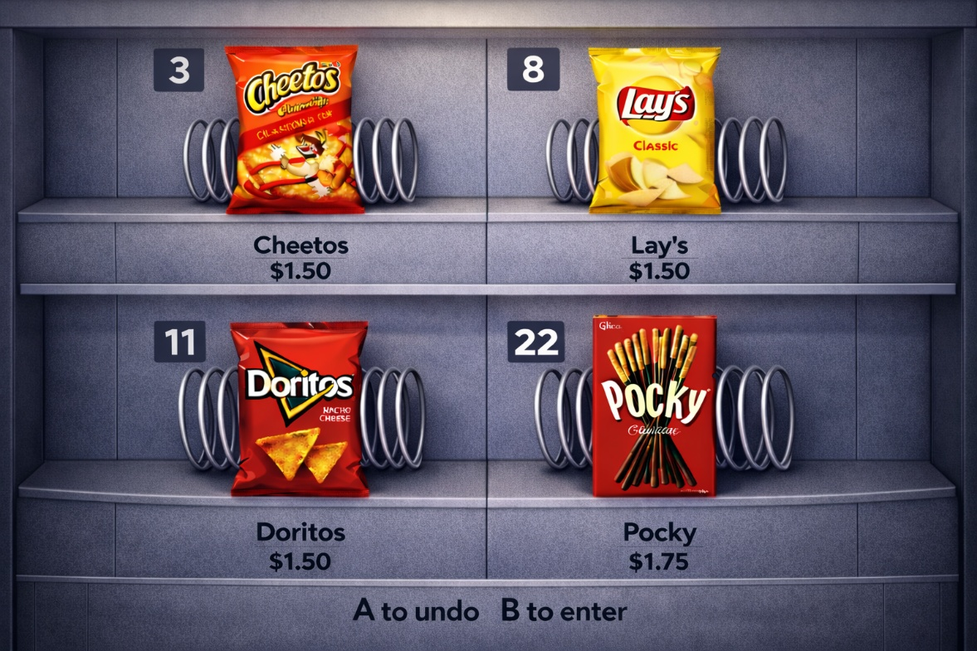

**Figure 1: Snack Selection Menu**

**Action:**

**Enter index number for snack (3/8/11/22)**

**Step 2a: Entered index is valid, snack is selected**

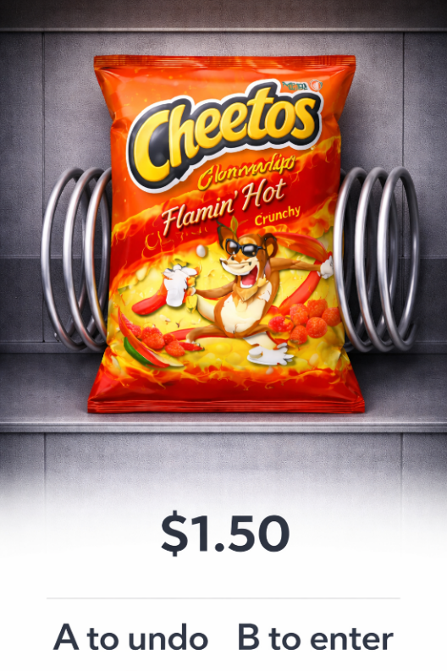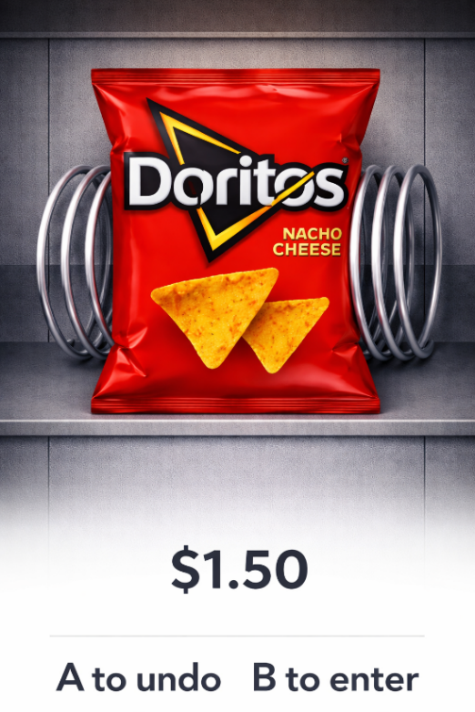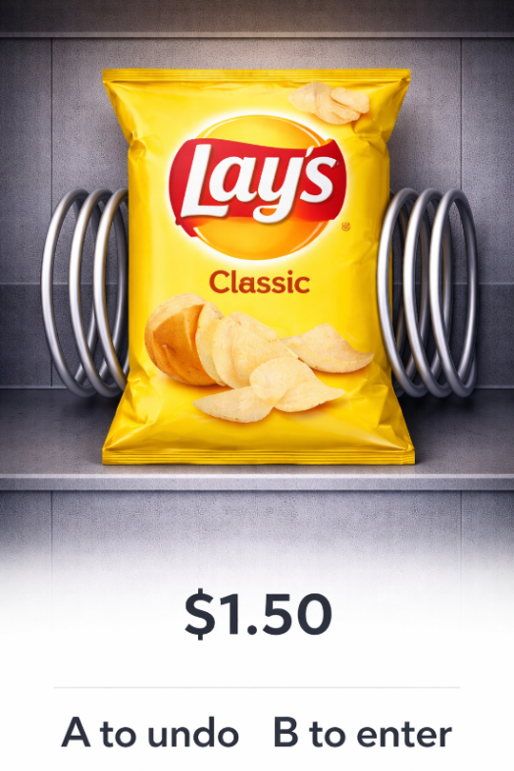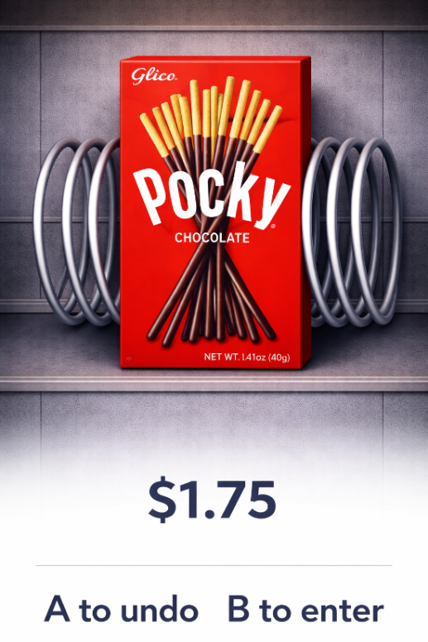

**Figure 2: Selected snack**

**Action:**

**Enter snack quantity**

**Double press 0 after confirming selection for payment**

**Step 2b: Selected Snack is out of stock**

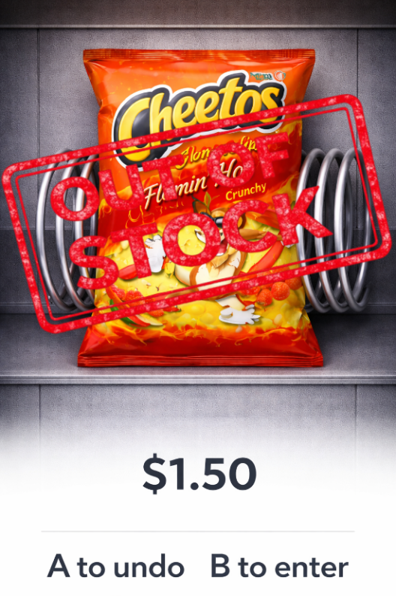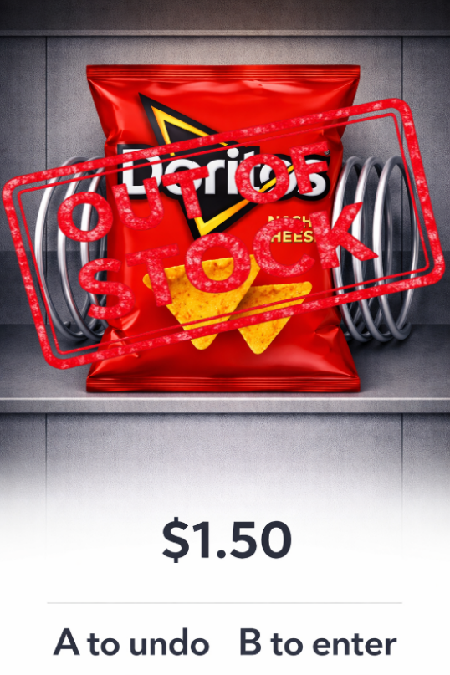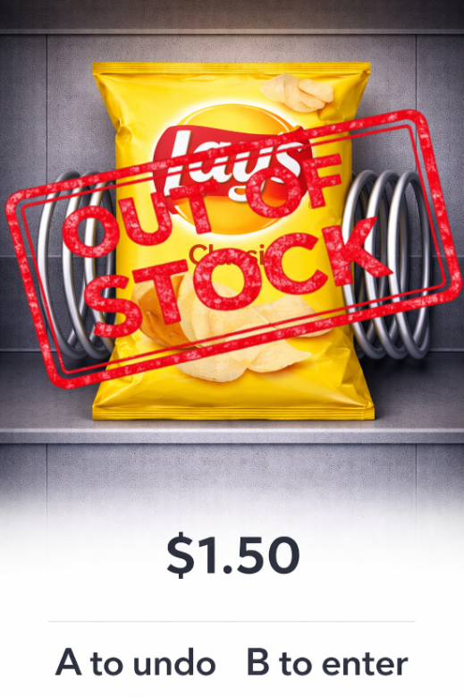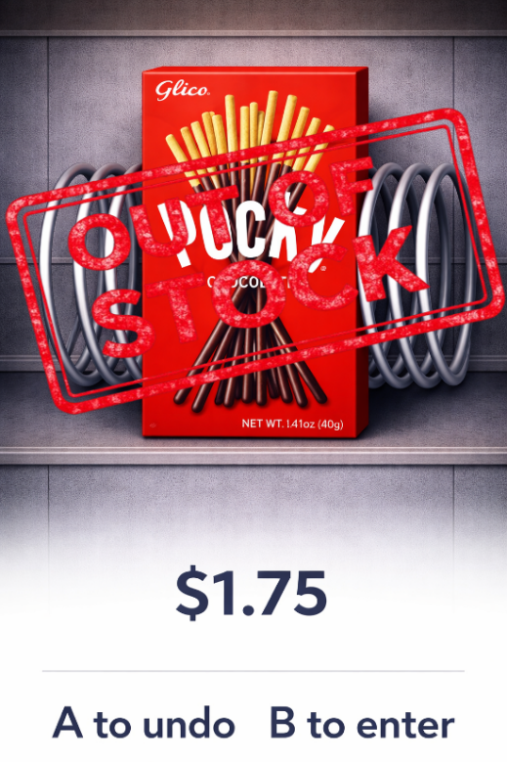

**Figure 3: Snack Out Of Stock**

**Action:**

**Wait 5 seconds to return to snack selection menu**

**Step 3: Dispensing in progress animation**

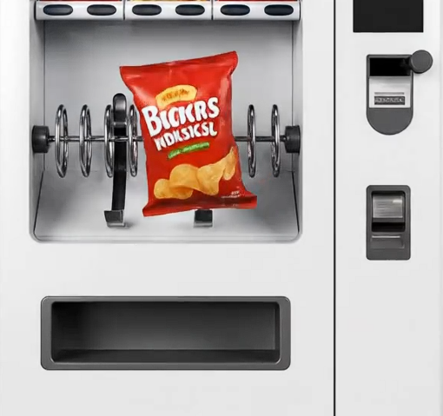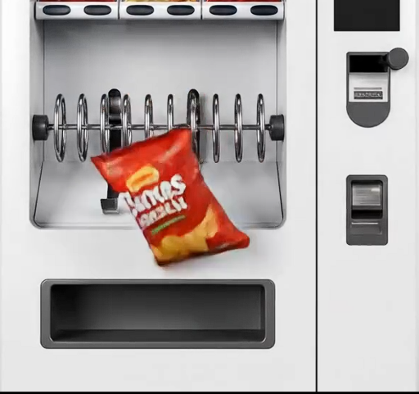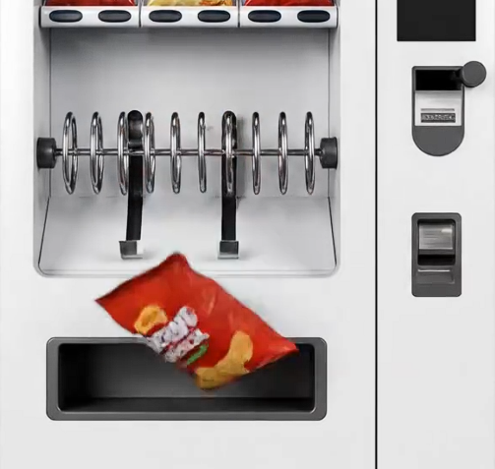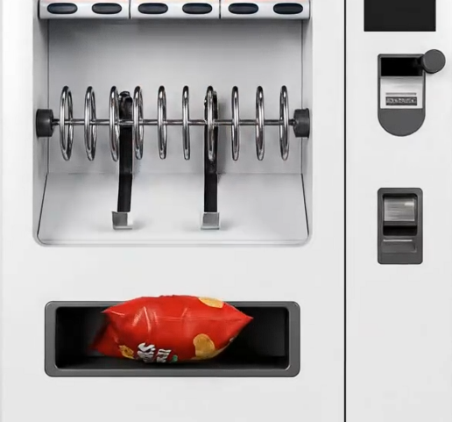

**Figure 4: Snack Dispense Animation**

**Action:**

**Wait for stepper motor to cycle X times (based on inputted snack quantity)**

**Step 4: Dispensing completed**



**Figure 5: Dispensing completed**

**Action:   
Wait 5 seconds to go back to Snack Selection Menu**

**Service Mode**

**Step 1: Entering Service Mode Animation**

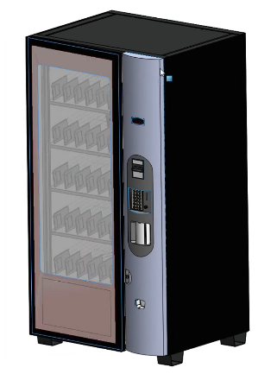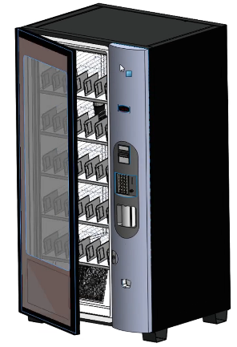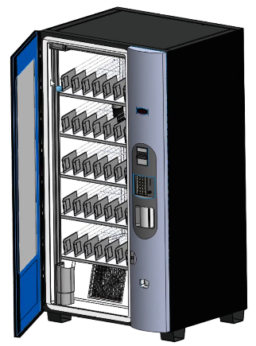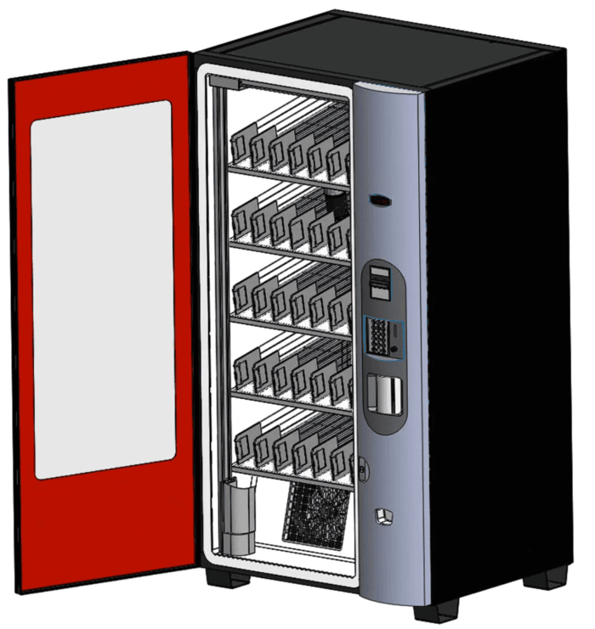

**Figure 6: Vending Machine Door Opening Animation**

**Actions:**

**Wait till the animation ends**

**Step 2: Service mode menu**

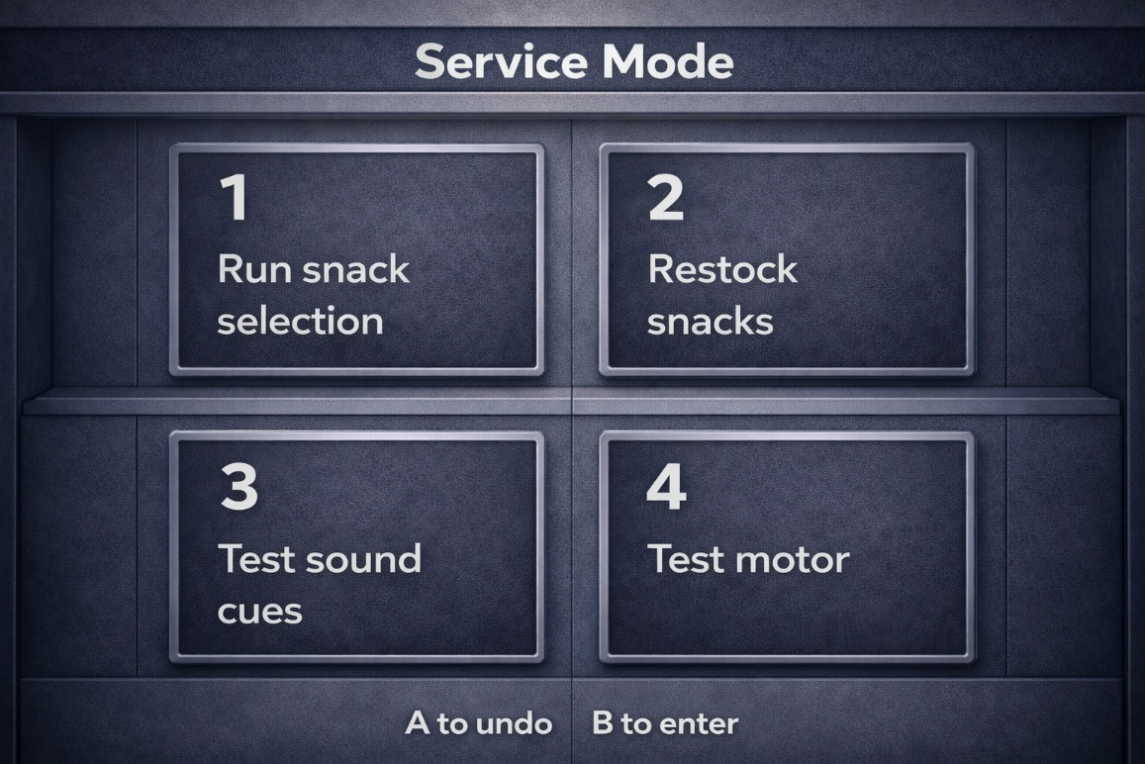

**Figure 6: Service Mode Menu**

**Action:**

**Enter function number (1/2/3/4)**

**Step 3a1: Service Mode snack selection (1 entered)**

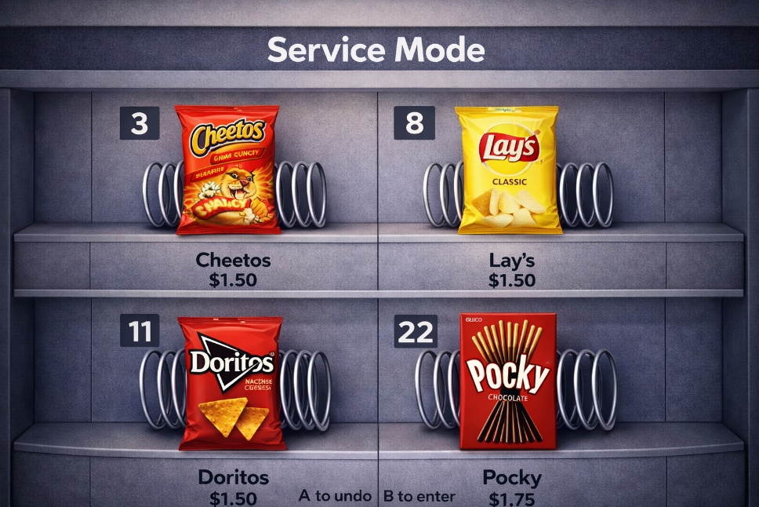

**Figure 7: Service Snack Selection**

**Action:**

**Enter index number for snack (3/8/11/22)**

**Step 3a2: Service Mode selected snack**

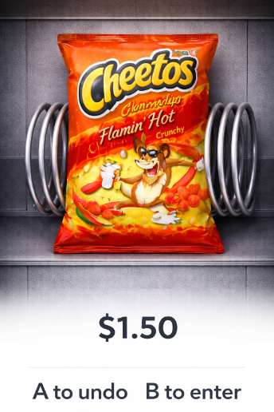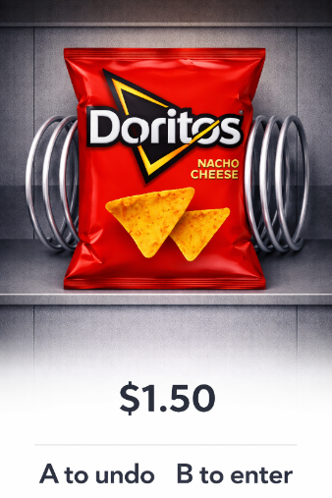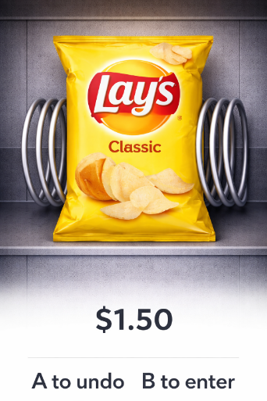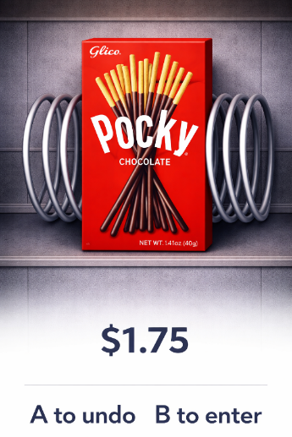

**Figure 8: Selected snack**

**Action:**

**Enter snack quantity**

**Step 3a3: Service mode dispensing animation**

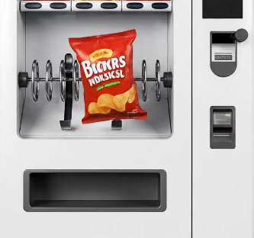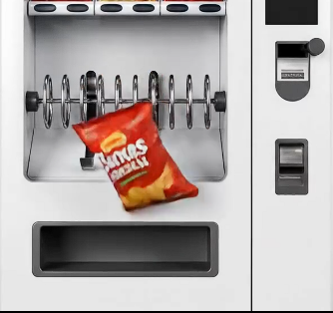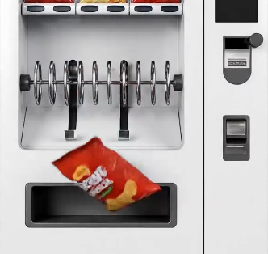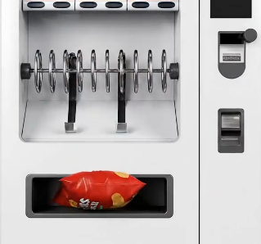

**Figure 9: Snack Dispense Animation**

**Action:**

**Wait for stepper motor to cycle X times (based on inputted snack quantity)**

**Step 2b: Restock vending machine (2 entered)**

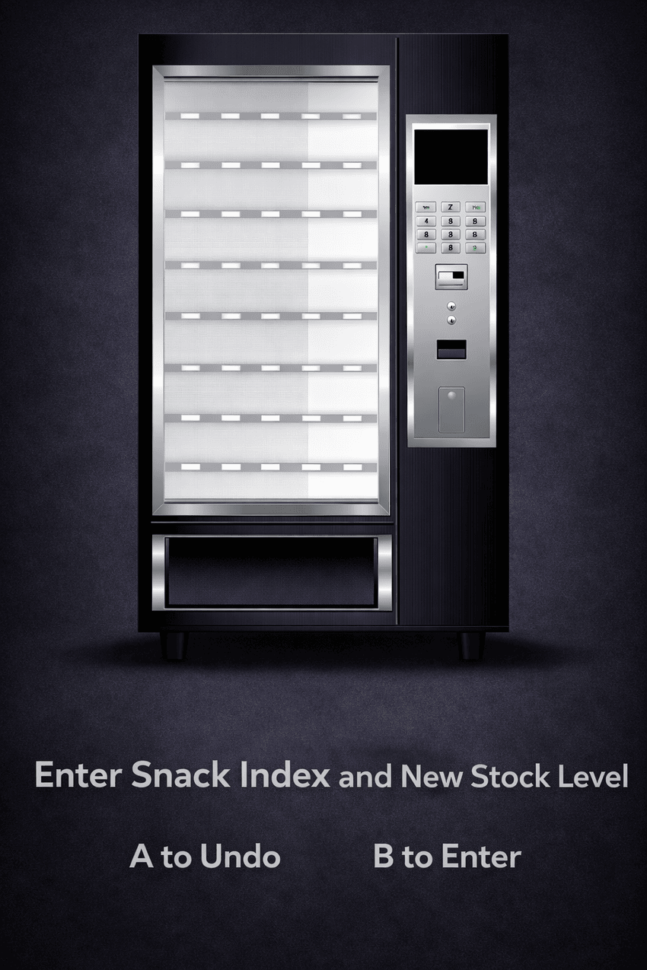

**Figure 10: Empty Vending Machine**

**Action:**

**Enter valid snack index (3/8/11/22)**

**Enter new stock amount**

**Step 3c: Menu for Sound Cue selection to test sounds (3 entered)**

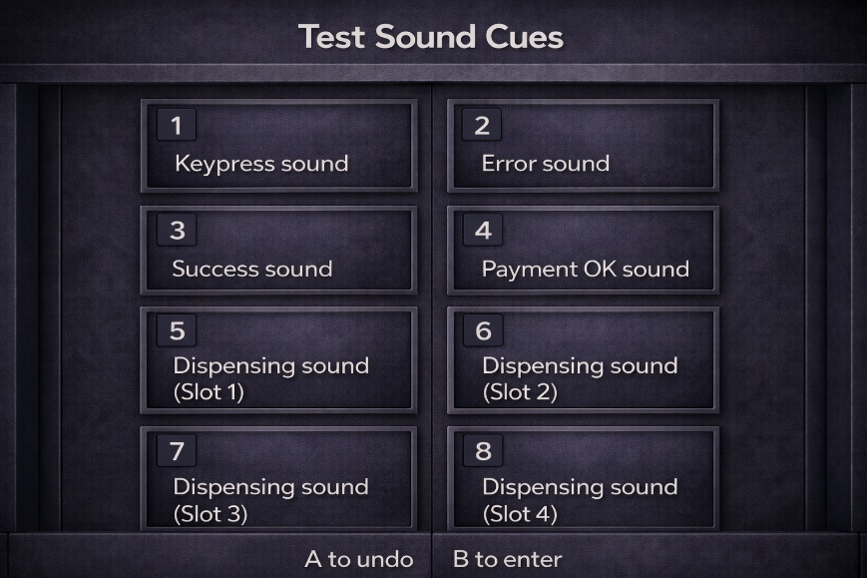

**Figure 11: Sound Cue selection menu**

**Action:**

**Enter valid Sound Cue index**

**Wait 1 second for sound to play**

**Step 3d: Motor spin test (4 entered)**

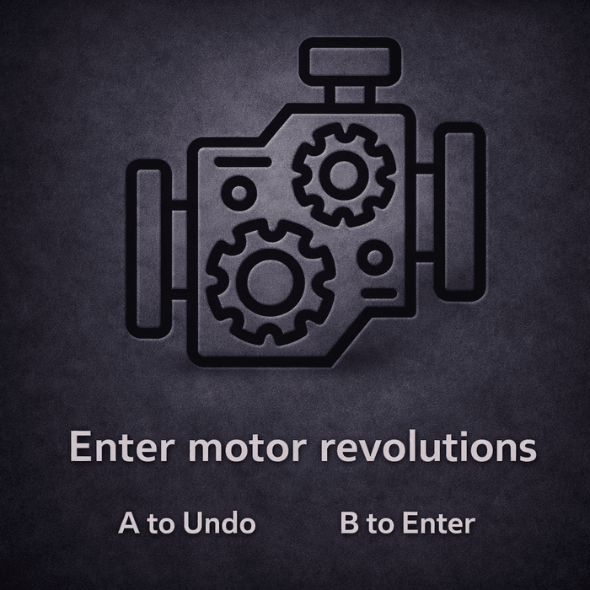

**Figure 12: Motor revolutions prompt**

**Actions:  
Enter Motor revolutions (1-15)**

**Wait till motor revolutions end**

**Step 4: Exiting Service Mode Animation**



**Figure 13: Vending Machine Door Closing Animation**

**Actions:**

**Wait till the animation ends**

**3. Use Case Diagrams**

**3.1 Actors**

* **User** – interacts with the system
* **Admin** – accesses Service Mode to perform system testing and maintenance.

**3.2 Use Case Diagram**

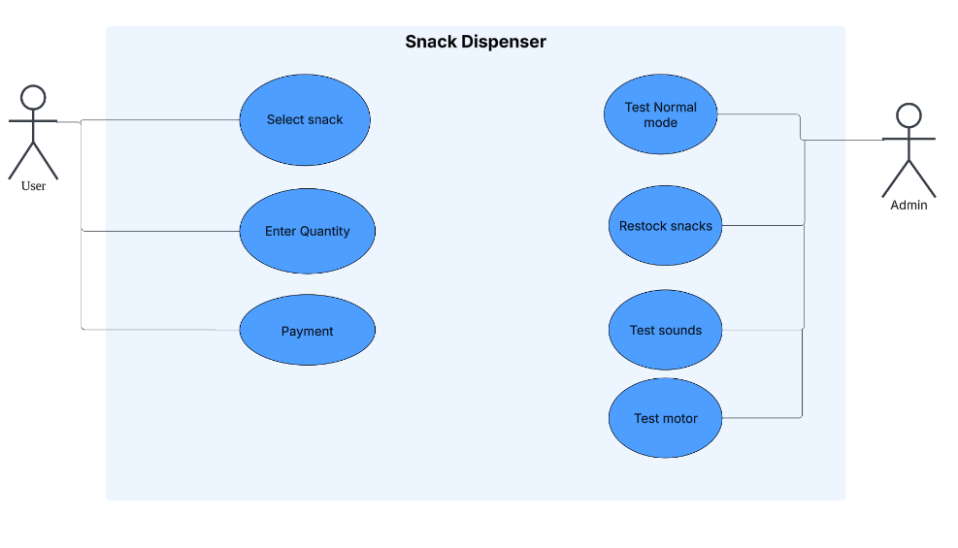

**Figure 14: Use case diagram (User, Admin)**

**3.3 Sequence Diagrams**

**Normal Mode**

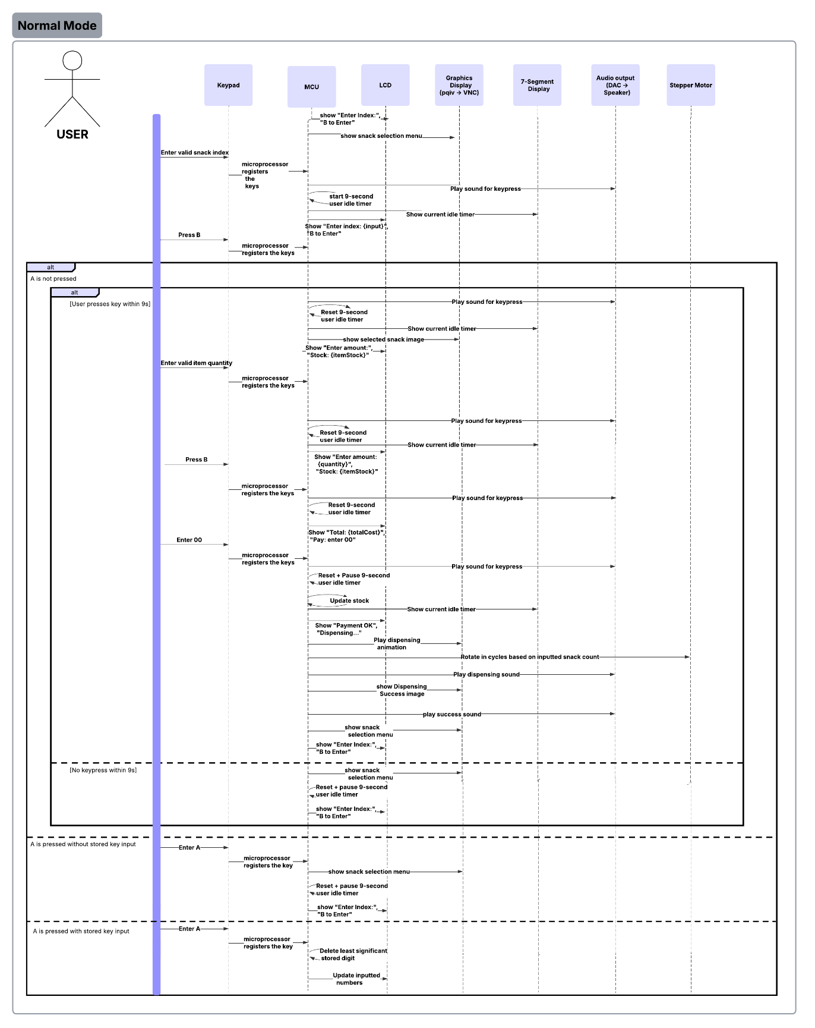

**Figure 14: Normal Mode Sequence Diagrams**

**Admin Mode**

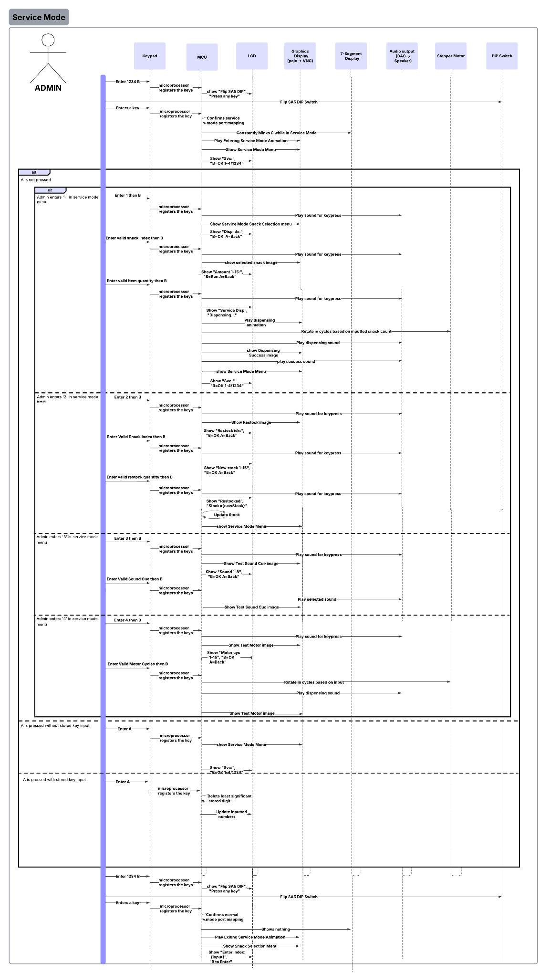

**Figure 15: Service Mode Sequence Diagram**

Student Name: **Nathan**  
Assigned Tasks:

* Core system implementation (state logic, control flow, and hardware coordination)
* Keypad scanning, input handling, and validation
* Service Mode design and DIP-gated access implementation
* Graphics engine implementation using pqiv (animation control and process management)
* Integration of system timing and concurrent operation handling

Student Name: **Meenakshi**  
Assigned Tasks:

* System implementation (UI flow, stock management, and service features)
* UML use case and sequence diagram design
* Stepper motor control and dispensing timing logic
* Report writing, formatting, and technical documentation
* System testing, validation, and error/edge-case behaviour verification

**9. WOW Factors**

* **Synchronized dispensing animation and motor control:** During dispensing, a frame-based animation (disp_1 → disp_4) runs alongside the stepper motor using a non-blocking animation engine. This is implemented through a shared Anim structure (gDispAnim) and anim_tick() function, which advances frames based on timestamp checks (now_ms()) instead of delays. The motor loop (run_one_dispense_cycle_with_anim()) repeatedly calls anim_tick() between phase updates, allowing animation and motor movement to execute concurrently without freezing the UI loop.
* **Rolling PID strategy for flicker-free image switching:** A fixed-size ring buffer (pqiv_ring[8]) stores the PIDs of active pqiv processes. Each show_image() call forks a new instance and inserts its PID into the ring. When the limit (8) is reached, only the oldest PID is terminated (kill_pid_soft_hard()), preventing full screen clears or killall usage. This maintains persistent rendering and eliminates desktop flicker during screen transitions.
* **Admin-mapping Service Mode gate:** Service Mode is protected through a dual-layer mechanism. Entering 1234 + B in normal mode triggers a gate state (ST_SVC_GATE), switches port mappings via set_port_mapping(1), and prompts the user to flip the DIP switch. A confirmation keypress is then required under the new hardware mapping before starting the door-opening animation and enabling service state.
  + **On entry:** After code validation, the system changes runtime port variables (gLedPort, gLcdPort, etc.) to the admin mapping and waits for confirmation before transitioning to ST_SVC_MENU.
  + **On exit:** Re-entering 1234 inside Service Mode triggers ST_RETURN_GATE, restores normal port mapping with set_port_mapping(0), and runs the door-closing animation before returning to the main menu state.
* **Custom DAC sound engine:** Audio feedback is generated using a low-level beep_square() routine that toggles DAC outputs (CM3PortWrite) between high and low amplitude values with controlled microsecond delays. Tone frequency is determined by the half-period delay, and duration by elapsed time checks (now_ms()).
  + Distinct wrapper functions (beep_keypress(), beep_error(), beep_success(), beep_payment_ok(), beep_dispensing_slot()) define event-specific tone patterns used throughout the state machine.
  + Service Mode includes a sound test state (ST_SVC_SOUND_SEL) that maps keypad selections (1–8) directly to these sound functions, allowing independent verification of each audio cue.